Dr. Kanika Mandi Chowdhury (1956 – 2019)

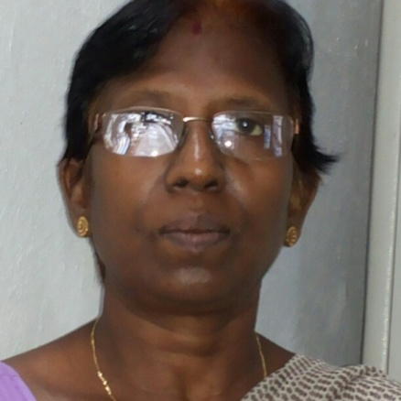

Dr. Kanika Mandi Chowdhury was born on 25th December, 1956. She passed MBBS from Medical College Kolkata in 1981. In 1985, she joined WBHS as medical officer.
She did Diploma in Clinical Pathology in 1997-’98 from School of Tropical Medicine, Kolkata; and obtained her MD in Biochemistry from MGIMS, Wardha, Maharashtra in 2007.
She joined WBMES and served as a faculty in different Medical Colleges in West Bengal. She also served as Assistant Secretary in Health Secretariat.
She had a strong personality but well known to friends and colleagues as a responsible and caring individual.
She passed away on 18th April, 2019 after bravely fighting cancer till her last. She is survived by her husband, daughter and son.
May her soul rest in peace.
Tribute by -Prof. Santa Saha

