Professor Pradip Kumar Saha (1953 – 2017)

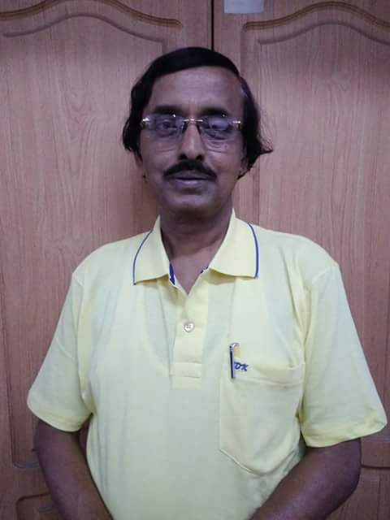
Dr. Pradip Kumar Saha was a senior member of our association. He was born on 4th April, 1953. He passed Higher Secondary Examination in the year 1969 from South Suburban High School, Bhowanipore and got admitted in Calcutta National Medical College for MBBS course. He passed M.B.B.S. in the year 1977 from Calcutta University and did M.D. (Biochemistry) from the same university. He joined the West Bengal Health Service in 1979. He served several medical colleges in various capacities. He was associated with me as Joint Director of Medical Education, where he looked after different judicial cases. During his posting as Joint Director of Medical Education, he had a severe heart attack and he had undergone bye-pass surgery. Then he came back to his mother Institute as Professor of Biochemistry. Later he became Principal of Murshidabad Medical College.
He was a very open-minded person. He often expressed his views without thinking the outcome. He was a music lover and used to sing without any inhibition. He was very down to earth in nature and he interacted freely with employees. Suddenly he left us on 7th August, 2017. Now he is survived by his wife, son & daughter-in-law.
Tribute by - Prof. C.R. Maiti

