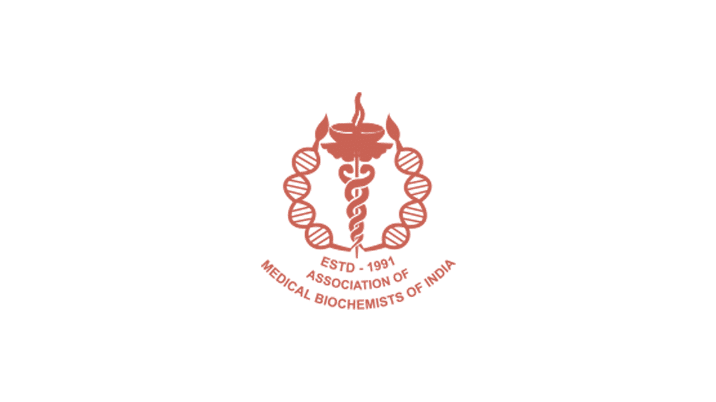
Association of Medical Biochemists of India, West Bengal Chapter
cordially invites you for the CME on :
“BIOCHEMISTRY &THE CHANGING SCENARIO OF ANEUPLOIDY SCREENING:
QUO VADIS”
On 22nd December, 2018 at
Department of Biochemistry, Nil Ratan Sircar Medical College
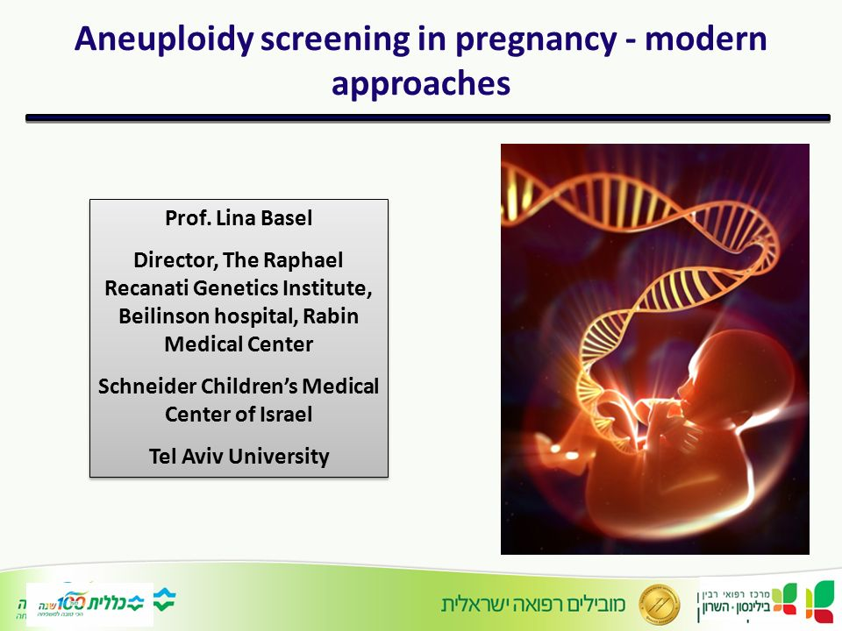

It will be followed by a PGT meet for Poster presentation and Quiz competition
Further information will be uploaded soon.

